Total = £30,060

Materials = £29,218

Total + labour (material) = £ 59,278

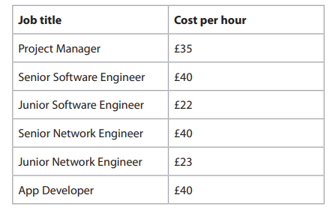

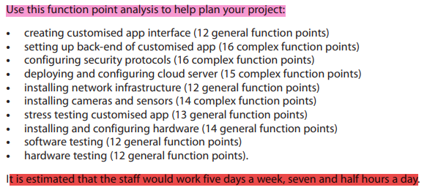

1. The **Junior Network Engineers** will work on:

• installing network infrastructure

• hardware testing

• installing and configuring hardware

Junior network engineer = £23 cpr

install network inf = (12 general function)

hardware testing (12 general function points)

installing and configuring hardware (14 general function points)

1. The Junior Software Engineer will work on: • stress testing the customised app • software testing.

stress testing customised app (13 general function points)

software testing (12 general function points)

1. The Senior Network Engineer **needs five hours per general function point and eight hours** per complex function point.

• installing network infrastructure • hardware testing • installing cameras and sensors

installing network infrastructure (12 general function points)

hardware testing (12 general function points).

• installing cameras and sensors (14 complex function points) *8

1. The Senior Software Engineer will work on:

• deploying and configuring of a cloud server

• software testing.

The Senior Software Engineer **needs five hours per general function point and eight hours** per complex function point.

deploying and configuring cloud server (15 complex function points)

software testing (12 general function points)

1. The App Developers will work on:

• configuring security protocols

• setting up the back-end of the customised app

• creating customised app interface.

The App Developers need **five hours per general function point and eight hours per complex function point**

